

**DBS Project Submission**

BTech IT (B1) – V SEMESTER

DEPARTMENT OF I&CT, MIT, MANIPAL

**Portfolio Management System**



ER Diagram & Normalization Table

**ABSTRACT**

In present scenario of our country, investors on the field of share market

are increasing day by day. With hiking shares, people are investing their

capital so that it profits them in the future reference. Likewise, people are

crazily indulged in this field which may create messy circumstances for

managing huge bundles of shares that they hold.

Also, in this busy era

people have no time to analyze fundamental, technical details and the

news related to that scrip.

Portfolio management system is in rescue for

this task.

**BY:**

**SHREYANSH RAI – 200911094**

**RAZA ABBAS - 200911104**

**ENTITIES**

* Company price
* Company profile
* Watchlist
* Holdings
* User
* Fundamental Report
* Technical Signals
* Dividend History
* News
* Transaction

**ER DIAGRAM**

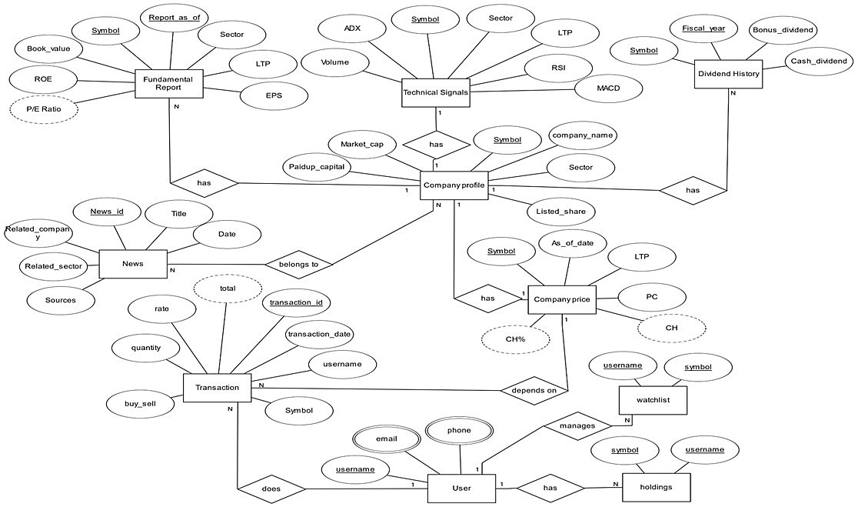

**CARDINALITY RATIOS**

* Fundamental Report has many-to-one relationship with Company Profile.
* Technical Signals has one–to–one relationship with Company Profile.
* Dividend History has many-to-one relationship with Company Profile.
* Company Profile has one–to–one relationship with Company Price.
* Company Profile has many–to–many relationship with News.
* Company Price has one–to–many relationship with Transaction.
* User has one–to–many relationship with Transaction.
* User has one–to–many relationship with Watchlist.
* User has one–to–many relationship with Holdings.

**PARTICIPATION CONSTRAINTS**

* There is total participation of entity ‘Fundamental Report’ with the ‘has’ relationship in the ER diagram.
* There is total participation of entity ‘Technical Signals’ with the ‘has’ relationship in the ER diagram.
* There is total participation of entity ‘Dividend History’ with the ‘has’ relationship in the ER diagram.
* There is total participation of entity ‘Company Price’ with the ‘has’ relationship in the ER diagram.
* There is **partial participation** of entity ‘Company Profile’ with the ‘belongs to’ relationship with ‘News’ in the ER diagram.
* There is **partial participation** of entity ‘Company price’ with the ‘depends on’ relationship with ‘Transaction’ in the ER diagram.
* There is total participation of entity ‘User’ with the ‘does’ relationship in the ER diagram.
* There is **partial participation** of entity ‘User’ with the ‘has’ relationship with ‘Holdings’ in the ER diagram.
* There is total participation of entity ‘User’ with the ‘manages’ relationship in the ER diagram.

**SCHEMAS**

* Fundamental Report: Symbol, Report_as_of, LTP, EPS, P/E Ratio, ROE,

Book_value

* Technical Signals: Symbol, LTP, RSI, MACD, Volume, ADX
* Dividend History: Symbol, Fiscal_year, Bonus_dividend, Cash_dividend
* News: News_id, Title, Date, Sources, Related_company
* Transaction: Transaction_id,Transaction Date, username, Symbol, Quantity, Rate, Total
* Company price: Symbol, LTP, PC, CH, CH %
* Watchlist: username, symbol
* Company profile: Symbol, company_name, Sector, Listed_share, Paidup_capital, Market_cap
* User: username, email, phone, password

**NORMALISED TABLES**

**Fundamental Report:**

|  |  |  |  |  |  |  |
| --- | --- | --- | --- | --- | --- | --- |
| Symbol | Report_as_of | LTP | EPS | P/E Ratio | ROE | Book Value |
|  |  |  |  |  |  |  |

**Technical Signals**

|  |  |  |  |  |  |
| --- | --- | --- | --- | --- | --- |
| Symbol | LTP | RSI | MACD | Volume | ADX |
|  |  |  |  |  |  |

**Dividend History:**

|  |  |  |  |
| --- | --- | --- | --- |
| Symbol | Fiscal year | Bonus dividend | Cash dividend |
|  |  |  |  |

**News:**

|  |  |  |  |  |
| --- | --- | --- | --- | --- |
| News id | Title | Date | Sources | Related company |
|  |  |  |  |  |

**Transaction:**

|  |  |  |  |  |  |  |
| --- | --- | --- | --- | --- | --- | --- |
| Transaction id | Transaction Date | username | Symbol | Quantity | Rate | Total |
|  |  |  |  |  |  |  |

**Company price:**

|  |  |  |  |  |
| --- | --- | --- | --- | --- |
| Symbol | LTP | PC | CH | CH% |
|  |  |  |  |  |

**Watchlist:**

|  |  |
| --- | --- |
| username | Symbol |
|  |  |

**Company profile:**

|  |  |  |  |  |  |
| --- | --- | --- | --- | --- | --- |
| Symbol | Company_name | Sector | Listed_share | Paidup_capital | Market_cap |
|  |  |  |  |  |  |

**User:**

|  |  |  |  |
| --- | --- | --- | --- |
| username | email | phone | password |
|  |  |  |  |

**JUSTIFICATION FOR NORMALIZATION**

* All the above tables are in **3NF** forms.
* By normalizing it in 3NF form, we made sure that there **is no functional dependency** between 2 non-prime attributes.
* NON-PRIME ATTRIBUTES: Set of attributes which do not participate in the formation of the candidate key of a relation.
* All these tables do not have any anomalies (**insertion, deletion, updation**).
* All these tables do not show any **row level** or **column level data redundancies**.